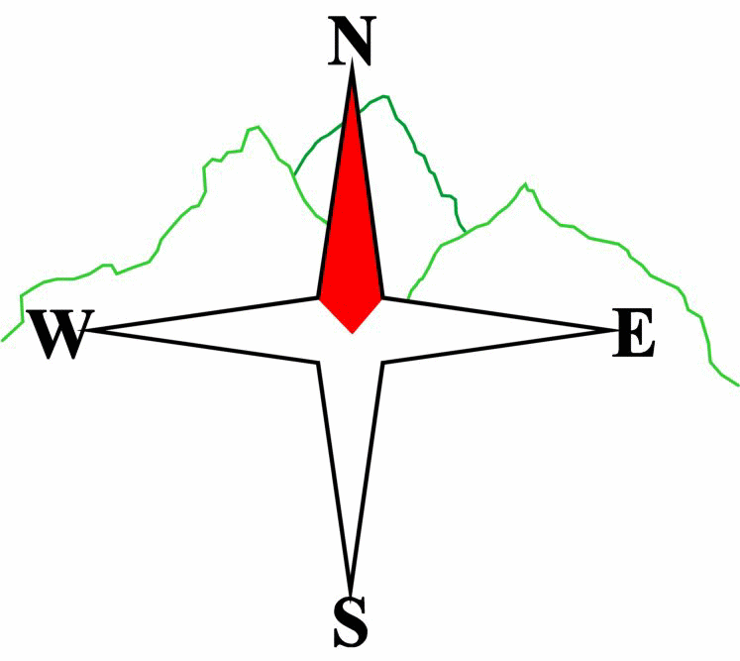***Blairgowrie & District Hillwalking Club***

**Web site: www.bdhc.org.uk**

**Carn an Tuirc Circular**

**Map 43**

**23 June 2024**

|  |  |  |  |  |
| --- | --- | --- | --- | --- |
| **Car Meet :** | **Blairgowrie** (**Wellmeadow**): **08:00** | | **Alyth** (**Square**): **07:45** | |
|  | | | | |
| A Walk – Cairn of Claise – Carn an Tuirc Circular | | | | |
| Starting from carpark on A93 north of ski centre at NO 148 799, cross burn twice and follow track SE to Sron na Gaoithe (814 m) then continue in same direction up ridge to col at 170 777. Take track NE to Cairn of Claise (**M 1064 m**). Descend N for c.1 km before climbing NW then W to summit of Carn an Tuirc (**M 1019 m**). Descend N to ruined hut at 172 810 to reach path back to carpark.  Meet up with other groups at ski centre cafe. | | | | |
| Approx. distance: 12.3 km | | Total ascent: 654 m | | Min. **walking** time: 5 hrs |
|  | | | | |
| B Walk – Carn an Tuirc | | | | |
| Same starting point as A party. Cross bridge and follow path on N side of burn ENE to ruins of Carn an Tuirc Hut at 172 810 then climb southwards to Carn an Tuirc (**M 1019 m**). Make time to walk ENE from summit to cairn at 183 810 on the edge of scenic Coire Loch Kander to take in the view. Return to cars by the same route. Meet up with other groups at ski centre café. | | | | |
| Approx. distance: 10 km | | Total ascent: 546 m | | Min. **walking** time: 3½ hrs |
|  | | | | |
|  | | | | |
| C Walk – Carn nan Sac and Carn a Gheoidh | | | | |
| Start from carpark by ski centre cafe. Walking W between the ski lifts follow track on N side of burn in Butcharts Corrie NW then W past the hut. At 128 787 turn S looking for traversing paths to a col at 127 781 then rising SW to top of Carn nan Sac (920 m). From here in a westerly direction gradually ascend to Carn a Gheoidh (**M 975 m**). Return to cars via the same route.  Meet up with other groups at ski centre café. | | | | |
| Approx. distance: 10 km | | Total ascent: 434 m | | Min. **walking** time: 4 hrs @ 3kph |

|  |  |
| --- | --- |
| IMPORTANT: YOUR SAFETY IN THE HILLS | |
| **The Committee reminds members and guests of the following important points:** | |
| * You are responsible for your own safety * Club officials are not trained mountain leaders * Are you fit enough to complete your chosen walk in the available time? * Know where you are going on the walk and follow the route on your map. * Know how many are in your party and stay together | * Ensure you have enough food plus emergency rations * Carry a map & compass, survival bag, torch, whistle and small first aid kit. Know how to use them. * In winter conditions you must carry an ice axe on high level walks (club rule). You are also recommended to carry crampons. * **Learn** how to use your equipment. |
|
|
|
|
|  |
| **Club officials will be happy to give advice on any of these points if requested.** | |

**Please note that the Minimum walking times are based on reasonably fast walkers and assuming good conditions. The times do not include stops or breaks.**

## **In poor weather conditions or if members are not comfortable walking at 4km/hour then alternative or shorter routes should be considered.**

## The next club walk is on **Saturday 20 July**, train to Loch Rannoch then walk to Kingshouse Hotel starting at 08:00 (Blairgowrie) and 07:45 (Alyth).

Other information/events: Autumn Weekend, Kelso, 20-22 September. Get your accommodation organised!